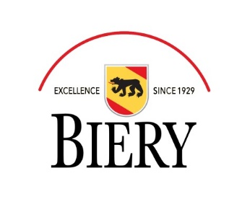
Position Title: Payroll Administrator

Reports to: Human Resource Manager

Schedule: Day shift

Job Summary:
The Payroll Administrator is responsible for the accurate and timely processing of bi-weekly payroll. Also responsible for compliance with all Federal, State and Local Regulatory Agencies. Provide customer service to internal and external customers.
Duties and Responsibilities
- Process payroll for approx. 600 employees at multiple locations (salary & hourly) using UltiPro
- Responsible for setting up and maintaining schedules to ensure all Federal, State, SUI and FUTA taxes are paid correctly and processing W-2 statements
- Process and monitor garnishment orders and other issues that impact payroll specifications
- Maintain and document all payroll records
- 401(k) plan administrator including completing audits and 5500
- Responsible for compliance requirements for DOL, ACA, etc.
- Participates in developing department goals, objectives, and systems.
- Electronically prepares and files EEO-1 report annually; maintains other records, reports, and logs to conform to EEO regulations.
- Participates in administrative staff meetings and attends other meetings and seminars as assigned.
- Assists in evaluation of reports, decisions, and results of department in relation to established goals. Recommends new approaches, policies, and procedures to effect continual improvements in efficiency of department and services performed.
- Maintains Human Resource Information System records and compiles reports from database.
- Provides backup to HR Generalist on benefits, FMLA, unemployment claims
- Available to work flexible hours as needed.
- Performs other related duties as required and assigned.
- Must maintain confidentiality of payroll, compensation, employee and financial information
Knowledge and Skills
Considerable knowledge of principles and practices of payroll and tax laws, employment fair labor practices, personnel administration, effective oral and written communication skills, excellent interpersonal skills. Must be self-starter and be able to problem solve/trouble shoot as issues arise. Advanced skill level in HRIS system, preferably UltiPro or Paycor. Strong skill level in MS Office.
Education and Experience:
- A bachelor's degree and three (3) to five (5) years of progressive payroll experience, preferably with UltiPro or Paycor
- Working knowledge of HRIS systems (UltiPro a plus)
- Prior human resource experience preferred
- Experience in a manufacturing environment helpful
- Certified Payroll Professional (CPP) or Professional in Human Resources (PHR) certification desired
Qualified applicants should apply at: www.bierycheese.com or contact Stephanie Janecek – HR Manager, sjanecek@bierycheese.com .

